Dear New Neighbor:

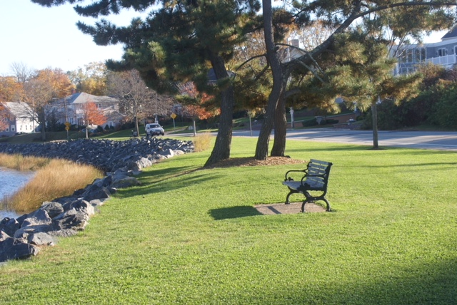
Welcome to the Edgewood neighborhood!!! As President of the Edgewood Waterfront Preservation Association (EWPA), we would like to invite you to a party to meet your neighbors and us on Sunday, September 30th at the home of Mark Garrison, 1499 Narragansett Boulevard. Bring your kids and, if the weather is good, we will adjourn the party to the Park across the way from Mark’s house. We plan to kick off this event at 2:00 PM and end around 4:00 PM.

To give you some background, EWPA is a non-profit organization established to preserve the waterfront in Edgewood. We, as a volunteer organization composed of Edgewood residents, have been around since the 1970s and our mission is to maintain and improve Edgewood’s waterfront. To give you an example of some of our activities in the area around Stillhouse Cove, we trim the trees, plant the grass, do the weeding, clean up the beaches and park, provide doggie bags, and maintain the rotary at the intersection of Narragansett Boulevard and Ocean Avenue. What you see at Stillhouse Cove is not what it was 20 years ago or even 10 years ago. We are constantly improving the Cove and welcome volunteers to help us. If you want to read more about us and the history of the Cove, visit our website at www.stillhousecove.org.

Refreshments will be served and we hope that you can join us. No RSVP is necessary and we look forward to seeing you on Sunday, September 30th, between 2 and 4 pm. If you cannot come and want more information about us, please contact me at brubine@verizon.net and I will be sure to get back in touch with you.

We look forward to meeting you on September 30th!

Barbara Rubine
President

